3.1 Attribute Selection
3 attributes have been selected: They are the following:
- amount of ad-clicking per user
- amount of game-clicking per user
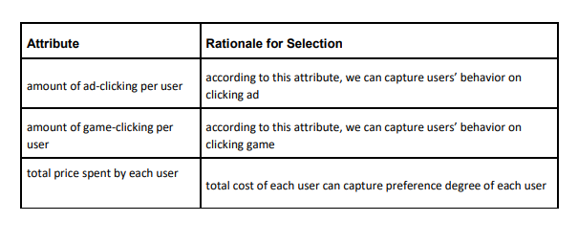
- total price spent by each user

